Week 8 assignment

Task 1: List regex that extracts dates from http://bit.ly/regexexercise2 and formats them as YYYY-MM-DD?
URL for the solution:
https://regex101.com/r/Xn8Fqr/1
Brief explanation:
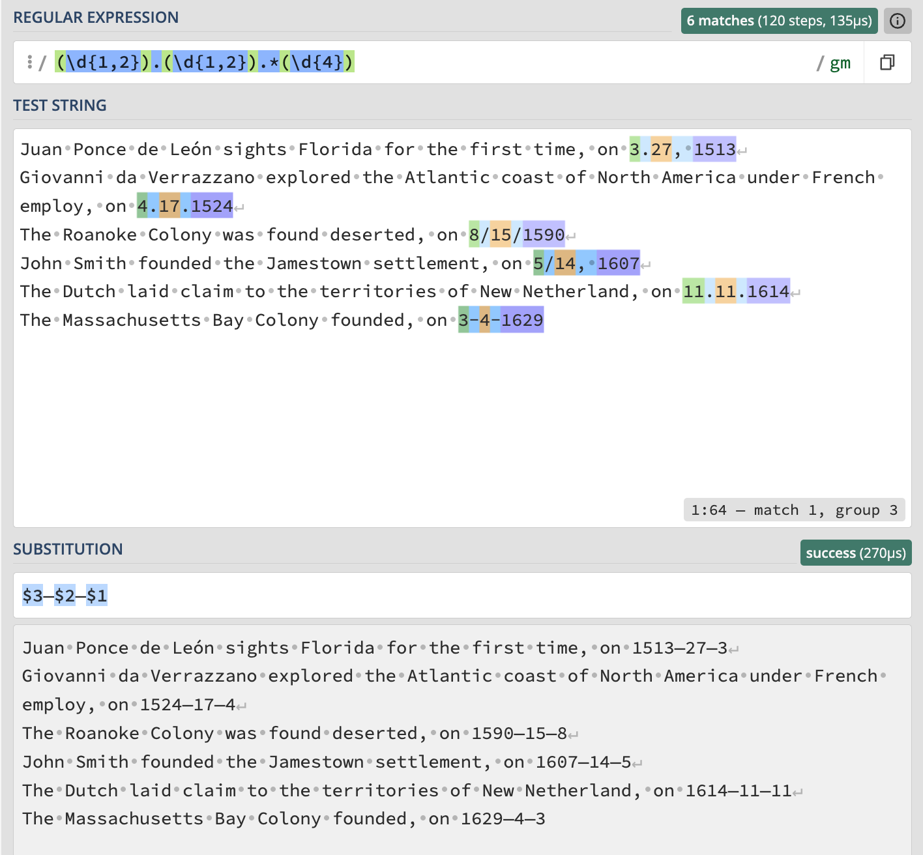
To concretely isolate the different parts of the dates we used the function (\d{1,2}) to isolate the first. For the second we did the same, but in this case we used “.” to assert the second capture group. For the third we used “.” again to mark the capture group but then put a “*” next to it to mark the date in the first line in the text, as its quantity of spaces is larger. Then to mark the year number we used the function (\d{4}).
After we marked all the dates, we used the substitution function to switch around the order of how the dates are written. To do this we used “$” to use a set capture group (For example $3). Then we finished the task by switching the order of the 3 capture groups, to make them the desired format of YYYY-MM-DD.

2. Write a regular expression to convert the stopwordlist (list of most frequent Danish words) from Voyant in http://bit.ly/regexexercise3 into a neat stopword list for R (which comprises "words" separated by commas, such as http://bit.ly/regexexercise4 ). Then take the stopwordlist from R http://bit.ly/regexexercise4 and convert it into a Voyant list (words on separate line without interpunction)
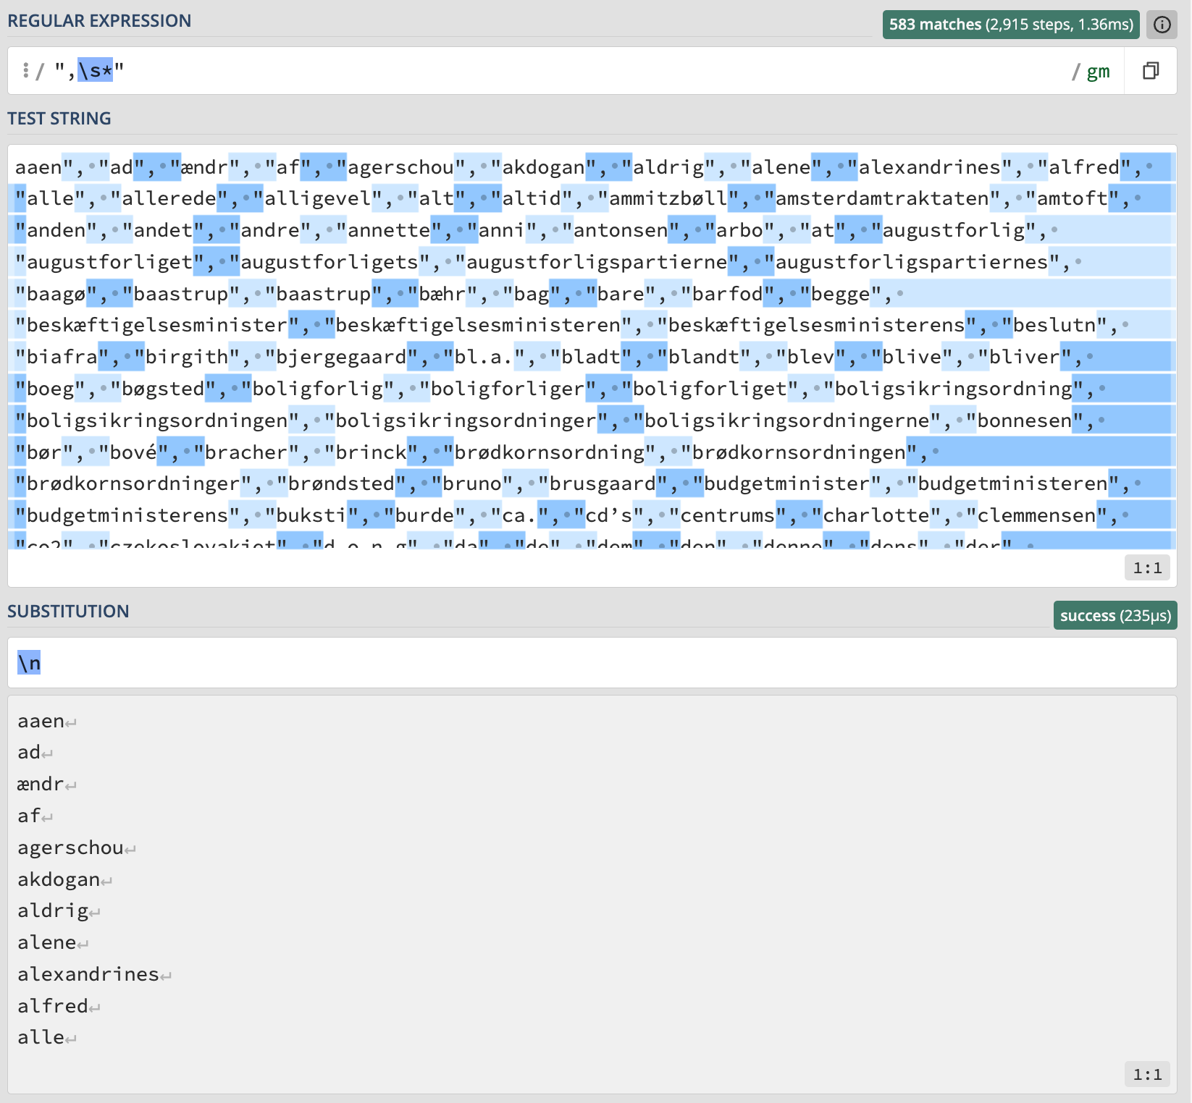
In order to replicate the dataset in Excel we’ve removed the commas, spaces and quotation marks. “ and , highlights the quotation marks and commas. \s matches any spaces, tabs or newlines in case the data has been formatted in the transfer from source to RegEx. By inserting a star * we make sure that any extra spaces, tabs or newlines are highlighted in case there are more than one. This formula highlights everything in between the words which make us able to remove it and replace it with a newline. \n substitutes the highlighted data with a newline.
Et voila!

3. Does OpenRefine alter the raw data during sorting and filtering?
Filtering in OpenRefine does not alter the raw data. The operations only change how the data is displayed. The original data remains intact unless an explicit transformation is applied. All changes in OP are recorded in the operation and can be undone at any time

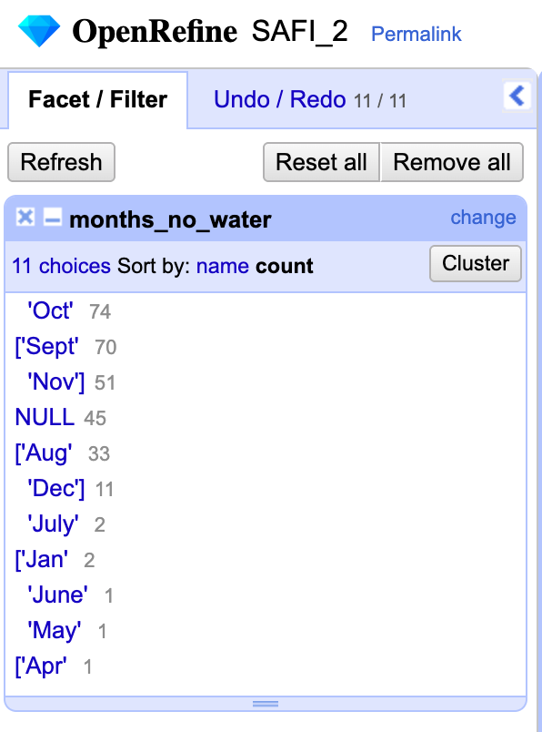
4. Fix the interviews dataset in OpenRefine enough to answer this question: "Which two months are reported as the most water-deprived/dryest by the interviewed farmer households?"

First I split the months into individual columns by selecting “edit cells” -> “split multi values cells, and split them by “;” after that I did a tight cluster, and got September and October as the most mentioned months of drought. →

5. Real-Data Challenge: What are the 10 most frequent occupations "erhverv" among unmarried men or women of 20-30 years in 1801 Aarhus census dataset? (hint: first select either men or women to shrink the dataset to a manageable size, then filter by age, and then use merging to cut the erhvervvariation ruthlessly.)
Answer: First, I filtered the data to include only individuals aged 20-30 years using a numeric facet on the age column. Next, I applied a text fcet on “civiltilstand” and selected “ugift”. Then I filtered by gender and selected men to reduce the dataset size. I used the cluster and edit function with the method “fingerprint” to merge spelling variations. Finally I created a text facet on the occupation column and sorted by frequency to identify the ten most common occupations
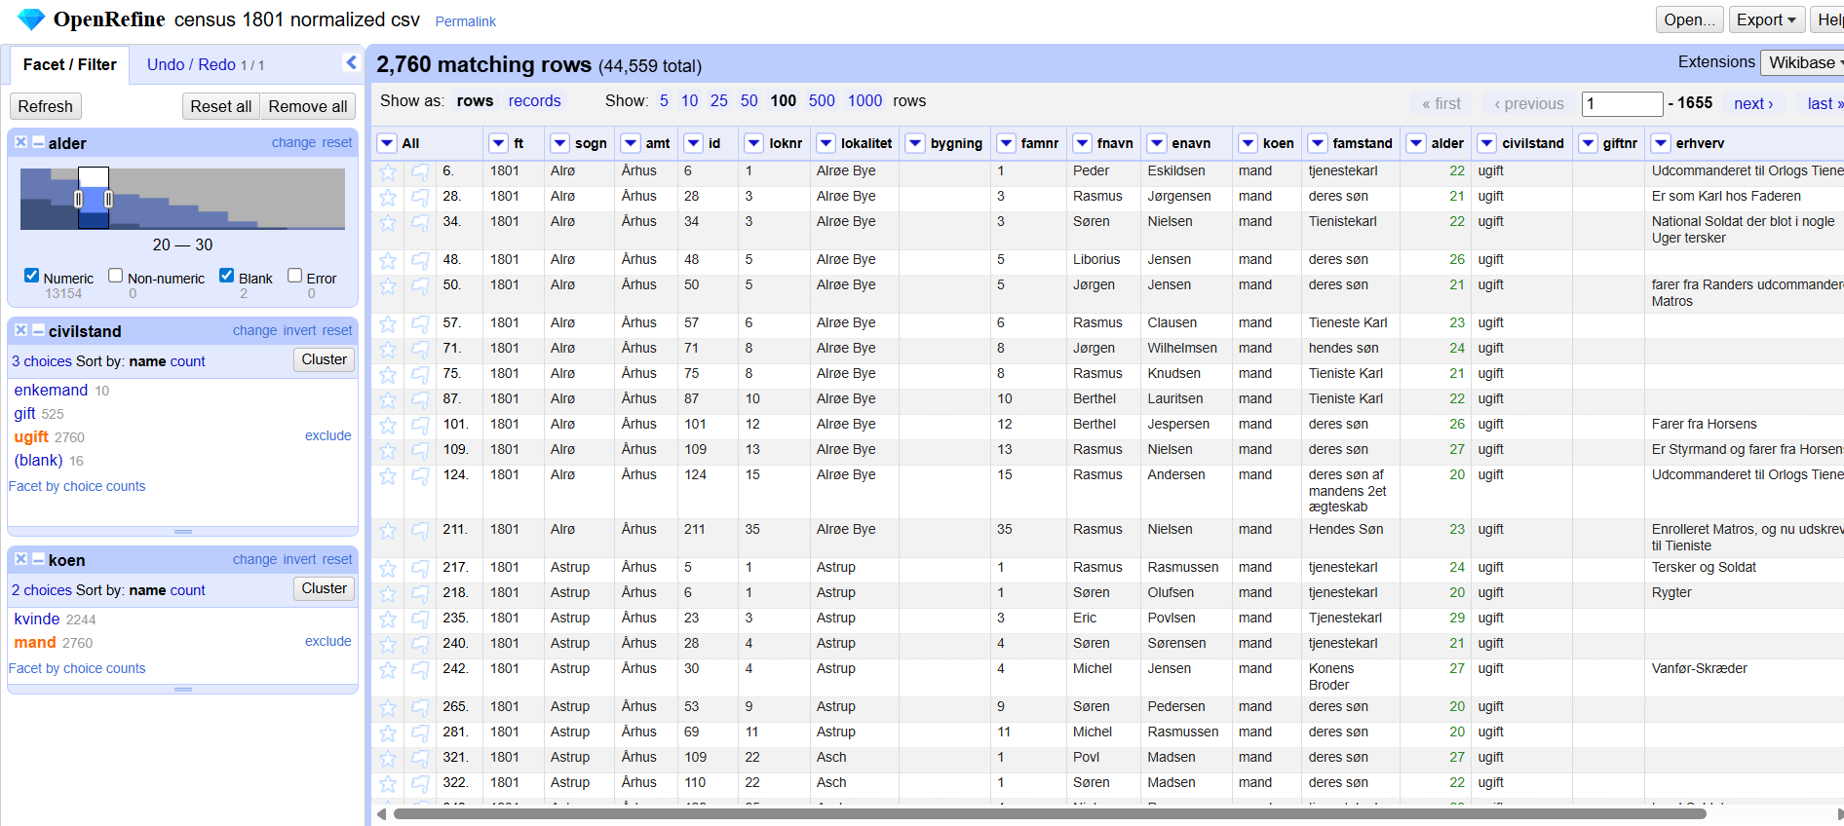
List of unmarried men in the age 20-30 years

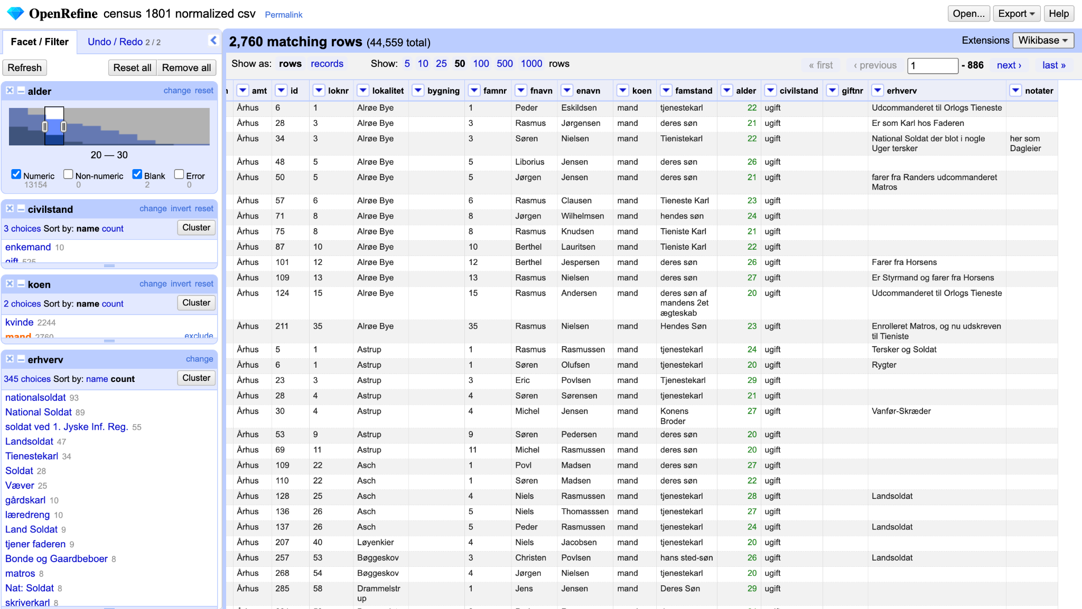
The 10 most frequent occupations "erhverv" among unmarried men or women of 20-30 years
- Nationalsoldat
- National Soldat
- Soldat ved 1. Jyske inf. Reg.
- Landsoldat
- Tjenestekarl
- Soldat
- Væver
- Gårdskarl
- Læredreng
- Lands Soldat

